- Introduction

  - Apache Hadoop

Apache Hadoop

The Apache™ Hadoop® project develops open-source software for reliable, scalable, distributed computing.

The Apache Hadoop software library is a framework that allows for the distributed processing of large data sets across clusters of computers using simple programming models. It is designed to scale up from single servers to thousands of machines, each offering local computation and storage. Rather than rely on hardware to deliver high-availability, the library itself is designed to detect and handle failures at the application layer, so delivering a highly-available service on top of a cluster of computers, each of which may be prone to failures.

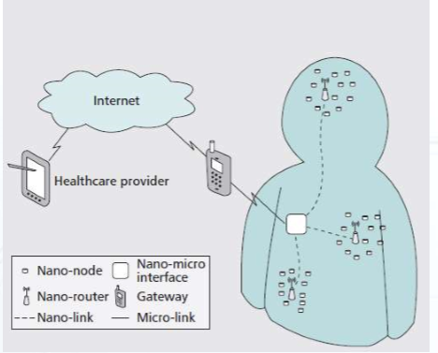

Figure 1: Insert your report image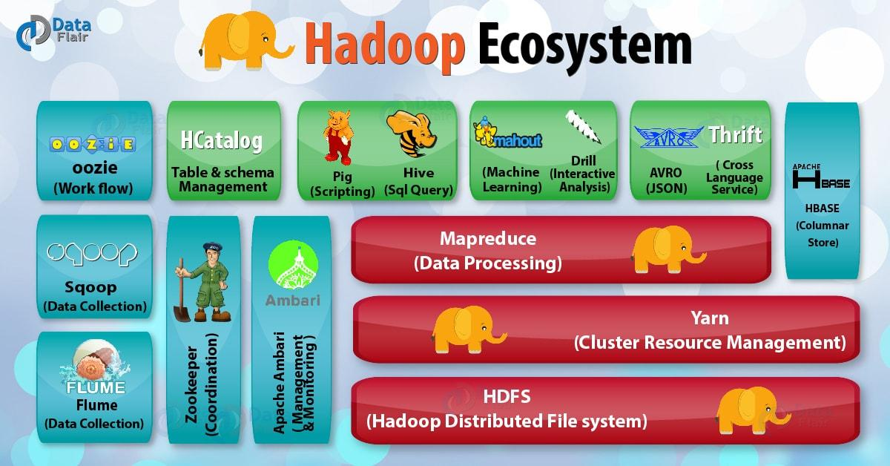

  - How many part of apache hadoop
HDFS (storage) and YARN (processing) are the two core components of Apache Hadoop.
HDFS is a distributed file system that handles large data sets running on commodity hardware. It is used to scale a single Apache Hadoop cluster to hundreds (and even thousands) of nodes. HDFS is one of the major components of Apache Hadoop, the others being MapReduce and YARN. HDFS should not be confused with or replaced by Apache HBase, which is a column-oriented non-relational database management system that sits on top of HDFS and can better support real-time data needs with its in-memory processing engine.
1.2.1 Meaning of HDES.
Hadoop Distributed File System (HDFS for short) is the primary data storage system under Hadoop applications. It is a distributed file system and provides high-throughput access to application data. It's part of the big data landscape and provides a way to manage large amounts of structured and unstructured data.
    - Meaning of YARN
YARN is an Apache Hadoop technology and stands for Yet Another Resource Negotiator. YARN is a large-scale, distributed operating system for big data applications. ... YARN is a software rewrite that is capable of decoupling MapReduce's resource management and scheduling capabilities from the data processing component.

    - Hadoop common
contains libraries and utilities needed by other Hadoop modules

    - Hadoop MapReduce
an implementation of the MapReduce programming model for large-scale data processing.

- Working of apache hadoop

1.2.1 Working of apache hadoop
Apache Hadoop is an open source, Java-based software platform that manages data processing and storage for big data applications. Hadoop works by distributing large data sets and analytics jobs across nodes in a computing cluster, breaking them down into smaller workloads that can be run in parallel

    - History of hadoop

Apache Hadoop was born out of a need to process growing large volumes of big data and deliver web results faster as search engine start-ups like Yahoo and Google were getting off the ground. Inspired by Google’s MapReduce, a programming model that divides an application into small fractions to run on different nodes, Doug Cutting and Mike Cafarella started Hadoop in 2002 while working on the Apache Nutch project. According to a New York Times article, Doug named Hadoop after his son's toy elephant. A few years later, Hadoop was spun off from Nutch. Nutch focused on the web crawler element, and Hadoop became the distributed computing and processing portion. Two years after Cutting joined Yahoo, Yahoo released Hadoop as an open source project in 2008. The Apache Software Foundation (ASF) made Hadoop available to the public in November 2012 as Apache Hadoop.

1.2.1

- Third Main Heading
Write Content from here
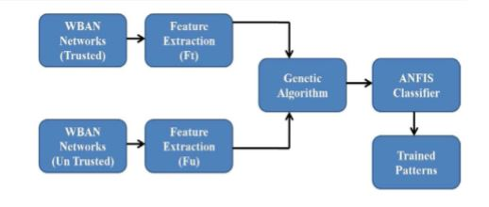
Figure 2: Insert Diagrams here

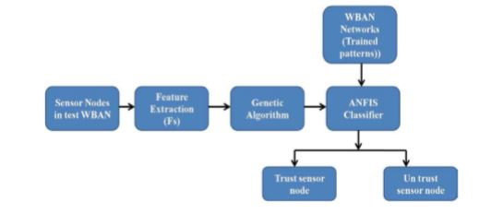

Figure 3: Testing Mode [15]

- Fourth Main Heading
Write content from here
4.1 Sub Heading
4.2 Sub Heading
4.3 Sub Heading
Write your content
4.4 Sub Heading
Write your content

6. Summary and Future Work
Write your content here

References

- Jing, L., Ming, L., Bin, Y., Wenlong, L., A Novel Energy Efficient MAC Protocol for Wireless Body Area Network. China communication, Feb. 2015.
- Negra, R., Jemili, I., Belghith, A.: Wireless Body Area Networks: Applications and Technologies. Procedia Computer Science 83, 1274 – 1281 ( 2016 )
- Yuce, M.R.: Implementation of wireless body area networks for healthcare systems. In: Sensors and Actuators A: Physical, Vol 162, Issue 1, Pages 116-129. Elsevier B.V (2010)
- Dabhi, K., Mahet, A.: Internet of Nano Things-The Next Big Thing. In: International Journal of Engineering Science and Computing, vol 7 Issue No.4 (2017)
- Negra, R., Jemili, I., Belghith, A.: Wireless Body Area Networks: Applications and Technologies. Procedia Computer Science 83, 1274 – 1281 ( 2016 )
- Yuan, X., Li, C., Ye, Q., Zhan, K., Cheng, N., Zhan, N., Shen, X.: Performance Analysis of IEEE 802.15.6-Based Coexisting Mobile WBANs with Prioritized Trafﬁc and Dynamic Interference. In: IEEE Transactions on Wireless Communications (Volume: 17, Issue: 8, Aug. 2018)
- Adhikary S., Chattopadhyay S., Choudhury S.: A Novel Bio-inspired Algorithm for Increasing Throughput in Wireless Body Area Network (WBAN) by Mitigating Inter-WBAN Interference. In: Chaki R., Cortesi A., Saeed K., Chaki N. (eds) Advanced Computing and Systems for Security. Advances in Intelligent Systems and Computing, vol 667. Springer, Singapore (2018)
- Peng, H., Tian, Y., Kurths, J., Li, L., Yang, Y., Wang, D.: Secure and energy-efﬁcient data transmission system based on chaotic compressive sensing in body-to-body networks. IEEE Trans. Biomed. Circ. Syst. 11(3), 558–573 (2017)
- Samanta, A., Misra, S.: Energy-efﬁcient and distributed network management cost minimization in opportunistic wireless body area networks. IEEE Trans. Mobile Comput. 17, 376–389 (2017)
- Ahmad, S.S., Razzaque, M.A., Inmaculada T.R., Hussain, N.: IEEE 802.15.6 Standard in Wireless Body Area Networks From a Healthcare Point of View. The 22nd Asia-Pacific Conference on Communications (APCC2016)
- Yi, C., Wang, L., Li, Y.: Energy efﬁcient transmission approach for WBAN based on threshold distance. IEEE Sensors J. 15(9), 5133–5141 (2015)
- Misra, S., Moulik, S., Chao, H.-C.: A cooperative bargaining solution for priority-based data-rate tuning in a wireless body area network. IEEE Trans. Wirel. Commun. 14(5), 2769–2777 (2015)
- Walsh, M.J., Hayes, M.J.: Throughput rate control for an 802.15.4 wireless body area network using static and low order anti-windup techniques. In: Proc. Mediterranean Conf. Control Autom, pp.1–6 (2007)
- Eberhart, R., Kennedy, J.: A New Optimizer Using Particle Swarm Theory. Sixth International Symposium on Micro Machine and Human Science, 0-7803-2676-8/95
- Kalaiselvi, K., Suresh, G.R. & Ravi, V.: Genetic algorithm based sensor node classiﬁcations in wireless body area networks (WBAN). Cluster Comput (2018)
- Nadeem, Q., Javaid, N., Mohammad, S.N., Khan, M.Y., Gull, M.: SIMPLE: Stable Increased-throughput Multi-hop Protocol for Link Efﬁciency in Wireless Body Area Networks. 26, Jul. 2013.

